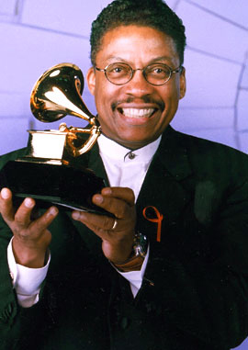
Grammy® - Best R&B Instrumental Performance - Rockit - 1983
Keyboard Magazine Readers Poll - Best Jazz & Pop Keyboardist - 1983
MTV Video Awards - Best Concept Video - Rockit - 1984
MTV Video Awards - Best Special Effects in a Video - Rockit - 1984
MTV Video Awards - Best Art Direction in a Video - Rockit - 1984
MTV Video Awards - Best Video Editing - Rockit - 1984
MTV Video Awards - Most Experimental Video - Rockit - 1984
Grammy® - Best R&B Instrumental Performance - Sound System - 1984
Gold Note Jazz Awards - NY Chapter National Black MBA association - 1985
Playboy Music Poll - Best Jazz Group - 1985
Playboy Music Poll - Best Jazz Album - Future Shock - 1985
French Award Officer of the Order of Arts & Letters - Paris - 1985
Oscar - Original Score - Round Midnight - 1986
BMI Film Music Award - Round Midnight - 1986
Playboy Music Poll - Best Jazz Keyboards - 1986
U.S. Radio Award - Best Original Music Scoring - Thom McAnn Shoes - 1986
Los Angeles Film Critics Association - Best Score - Round Midnight - 1986
Grammy® - Best Instrumental Composition - Call Sheet Blues - 1987
Playboy Music Poll - Best R&B Instrumentalist - 1987
Keyboard Magazine Readers Poll - Best Jazz Pianist - 1987
Keyboard Magazine Readers Poll - Best Jazz Keyboardist – 1987
Keyboard Magazine Readers Poll - Best Jazz Pianist - 1988
BMI TV/ Film Award - 25 Years of Affiliation - 1988
Playboy Music Poll - Best Jazz Instrumentalist - 1988
BMI Film Music Award - Colors - 1989
Grammy® - Best Jazz Instrumental Album by a Group - Tribute To Miles - 1994
Grammy® - Best Instrumental Composition - Manhattan (Island Of Lights And Love) - 1996
Soul Train Music Award - Best Jazz Album - The New Standard - 1997
Festival International Jazz de Montreal Prix - Miles Davis - 1997
Grammy® - Best Instrumental Arrangement Accompanying Vocal(s) - St. Louis Blues - 1998
Grammy® - Best Jazz Instrumental Performance - Gershwin's World - 1998
VH1's 100 Greatest Videos - Rockit is 10th Greatest Video - 2001
Grammy® - Best Jazz Instrumental Album - Directions In Music - 2002
Grammy® - Best Jazz Instrumental Solo - My Ship - 2002
Grammy® - Best Jazz Instrumental Solo - Speak Like A Child - 2004
NEA Jazz Masters Award - 2004

